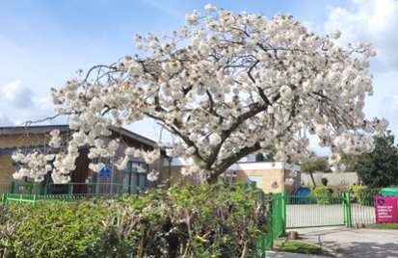

The Newsletter for Middleton on the Wolds

Issue No 37

MAY 2022

NEXT COPY DATE

14th MAY

Please send in your contributions by the end of the copy date. If I don’t acknowledge them please get in touch to make sure they have arrived.
If you are able to send your copy in earlier please do as it will help me to avoid the rush in getting the newsletter ready for the printer.
Thank you
Lyn
4 The Paddocks 219500 middletonflyer@yahoo.com

ADVERTISING COSTS for the Messenger

Rates Month Year
Whole Page £25 £150
1/2 Page £15 £100
1/3 Page £10 £60

Full colour - Print run 500 copies
Contact: Tina 01377 217242, middletonflyer@yahoo.com

Editorial
This month, I have been concerned, and not a little perplexed, by how little some residents seem to think about Middleton. Whether or not someone wants to be involved in the village is a personal decision and who could have a problem with that? What I do have a problem
with, though, is those people who don’t care about making the village a worse place for the rest of us.
Here’s a couple of examples.
In last month’s Messenger, the Rec Club brought our attention to the problem of dog fouling on the recreation ground. It’s been a while since I’ve talked about this in my editorial, and I’m sorry I have to again, but, as long as it keeps happening, I will keep talking about it. It was bad enough in winter but now it’s the cricket season and players will be throwing themselves round the outfield and, potentially, rolling in what your dog has left behind. And heaven forbid that kids might go and play up there and catch something other than a ball. I mean, just what is wrong with you people? Are you so important that you don’t have to bother about everyone else in the village? Perhaps you’d be better off not having a dog in the first place.
Now, we all know there is a problem with speeding in the village; not just at all four roads in, but also along Front Street, Station Road and Church Hill. Over the last few months, the neighbourhood Speed Watch has been operating in Middleton trying to encourage drivers to drive more slowly. All good, you might think, but I’ve heard that some locals have got a bit of a problem with ‘amateurs’ telling them how to drive. And I agree, civilians shouldn’t have to do the job of the police. On the other hand, there wouldn’t be a need for Speed Watch if people didn’t speed! And if locals are complaining, are they the ones speeding through their own village? And then to actually moan about it! How public spirited is that?
As I said earlier, I just don’t understand how or why someone would have that kind of attitude. Hopefully, that ‘someone’ could let me know! Stay safe,
Mike

If you have any ideas, comments or complaints (especially complaints) you want to share then send an email to middletonflyer@yahoo.com.
Remember, we can’t respond unless we receive your message.

QUIZ PAGE
- Only the lonely is a musical about which American singer?
- Which King was the present Queen’s grandfather?
- In the well-known saying what follows Pennywise?
- Which captain gave Botany Bay in Australia its name?
- Weegie' is a slang term for someone from which Scottish City?
- DI Jardine was the sidekick of which Scottish TV detective?
- Giallo is the Italian word for what primary colour?
- What Finish company created the N series of smartphones?
- Who wrote the Forsyte Saga series of novels?
- The Taj Mahal is mainly built from what colour marble?
Quiz set by Rowland Wooldridge
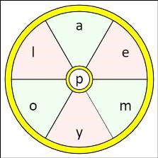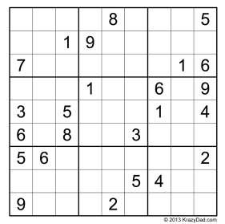
All answers on
page 22

Seasonal Word Wheel

Try to find the seasonal article and then
create as many words possible with the
letters in the word wheel. You can only
use each letter once and every word
must include the letter in the centre of
the wheel.

reading rooms
COIN & MEDAL
VALUATION
Thursday 5th May

Coin & Medal experts return to the East Riding to offer free no obligation valuations on Coins & Medals.
The team of expert valuers from the Medal Centre have been asked to return to the County to run another series of their ever popular coin & medal valuation days.
The experts from the medal centre are visiting Middleton on the Wolds reading rooms on Thursday May 5th 2022
The event is open to the public from 9.30am to 4.30pm. Everyone is welcome to attend and be offered a free no obligation valuation of their items with an immediate cash payment should they wish to sell the item?
The owner of the Medal Centre, Mr Andrew Jukes is an expert in all forms of British campaign & gallantry medals and is a member of the Orders & Medals Research Society. He also has expertise in all forms of militaria and has a passion for pocket watches and vintage watch chains
He is assisted at each event by a couple of members of his team of valuers who are experts in coins & bank notes, postcards, Masonic & R.A.O.B regalia along with swords, daggers and edged weapons, cloth & enamel badges, gold and silver coins & scrap gold & silver items including jewellery & silver tea sets / tableware.
At the last series of events Mr Jukes was thrilled to be able to purchase a small box of gold and silver coins along with a group of war medals and bravery medals to a local soldier of the East Riding Yeomanry. However he was probably not as thrilled as the lady owner of the items who walked away from the event with a four figure sum for her unwanted inherited items.
Why not call in at event No appointment is necessary and all you need to do is come along.
But if you cannot attend on the day the Medal Centre is always happy to arrange a home visit or housecall to see you at your convenience. All that you have to do is ring 01434-609794 or 07950-421704.

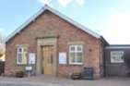
Village hall
Thank you to everyone who supported the recent Easter Fair, especially to those who helped in the kitchen and on the stalls. The hall looked bright and full of the joys of Spring and we were so lucky that the Easter Bunny hopped by and was happy to pose for photos with the visiting children.
A total of £420 was collected to help the unfortunate people of Ukraine and the table hire made about £100 towards Village Hall maintenance costs.
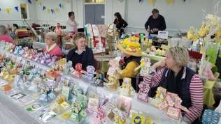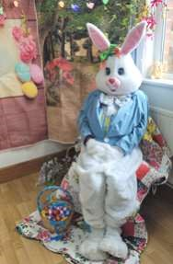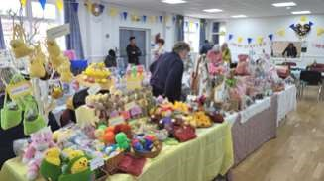

Local Birds & wildlife
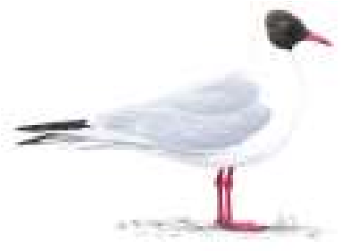
Happy Spring! Just coming up to Easter as I write this, and it sounds like it could be a good one: well, you will know if it was by the time you read this. I remember Easters when the news was full of sheep getting covered in
Black-headed gull Black-headed gull
snow, and for most of my childhood I
in summer in winter
associated the holiday with bitter winds and grey skies. And chocolate.
For once I had thought ahead for this page, and as I go into Driffield more regularly these days I was thinking about how now there are constant calls of seagulls over the town, and large groups of them gathering on the sports fields around Driffield School and the Leisure Centre. When I moved here this was completely unheard of so I thought I would take my binoculars and have a look at the seagully gatherings when I next went in, which would be the week of the deadline. An especially good idea as this would be when Driffield School would be closed, and on the whole it is probably not a good idea to be an adult appearing to be looking at schoolchildren through binoculars …
Unfortunately this visit proved to be the only time when there were no seagulls to be seen or heard at all. Did you know that birdy people do not recognise the term “seagulls”? I have been corrected that they are “gulls” and then there are the varieties: black-headed gulls (which do have black heads in summer, but only a smudge behind their ears in winter), herring gulls (not many herrings in Driffield), the common gull (pretty rare actually) and the frankly terrifying greater black-backed gulls which are enormous and have very black backs, so easily recognised. There are lots more of course (there is a laughing gull, which turns up occasionally in Britain, which has a particularly depressed expression – Google it for pics). So I will have another look another time!
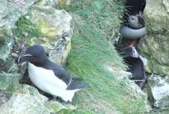
In the meantime, people who have actually seen things. Janny sent me some wonderful pictures from Bempton of razorbills and puffins on the rocks and crevices on the cliffs. Puffins often nest in burrows, but these seem to be checking out other sheltered options with burrows being in short supply there. Pat has had a lot of activity in her garden, with doves
nesting and producing a young one which she saw on 19th March although unfortunately they found it deceased at the bottom of their garden on
10th April – perhaps the cold temperatures overnight around then might have weakened it. However she was cheered by “when we had a hen pheasant actually walk up the garden and hop up the steps onto the deck this morning. Unfortunately it saw me attempting to get a photo through the window blind and took off over the school field. First time for a pheasant but we used to get a pair of French partridge who would come up and look in.”
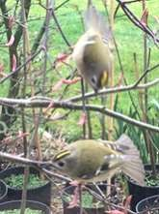
Andrew and Liz have made me jealous again: “We have these in our garden all day” a very cheering email accompanied as it was by three lovely pictures of goldcrests (one of my favourite birds). I wondered if there is more cover for them there than now in our garden since the trees on the embankment were cut back, but apparently not: “Not sufficient cover in our garden. They’ve spent all day in the acer right outside the French doors. Are they admiring their reflections in the glass? Certainly they don’t seem to be searching for insects/spiders … They were unperturbed by us on our side of the glass just feet away. I speak to Barry and Jannie about the visitors they get to their feeders and it’s like we’re in a different
county. We feed sunflower hearts – birds are principally blue and great tits, chaffinch, goldfinch and greenfinch. More recently we’ve had hedge sparrows (aka dunnocks – B) and also starlings and male blackbird taking advantage of meal worms.”
So who knows what will turn up in your garden – please let me know when they do! Barbara lavenderbarbara97@gmail.com or text on 0777 192 7868
DATE FOR YOUR DIARY

Middleton Produce Show

Saturday 17th September 2022

Schedules will be delivered

later in the year

Sue Howden

Show Secretary

LOCAL HISTORY

MIDDLETON’S HOUSES
“Safe as Houses,” the phrase rings hollow when one considers the unceremonious demolition of the Hall in about 1960 and Manor Farm in the 1970s; the latter after an unsuccessful struggle for its retention by John Goodrick. Possibly the oldest existing house in Middleton is the one near the pond which is built of chalk, originally as a block of cottages and presently known as “Quackers” which the local authority’s listing decription and the second edition of the Pevsner Guide date as early 18th century. Paul Martin, a former owner, carried out an investigation of its history and
established that its previous uses included a saddle ^{Peter Atkinson Jr} shop and village shop. A previous owner was the widow of a clock maker (Appleton) whose family owned the property and many others in the village for over 100 years. The main garage was a coach house and the extension was a 2 storey, 2 bedroomed cottage which apparently housed a family during the construction of the railway. The property known as the White House in Station Road also consists of some construction work in chalk as does the present dwelling opposite Wold House Farm formerly Wold Cottages situated away from the village and built in 1847 for agricultural workers and incorporating a Wesleyan Methodist Chapel.
In pre-enclosure days chalk was the building material of the Wolds, often with mud instead of lime mortar and with thatched roofs. Chalk was not an ideal material because it is porous: water easily soaks into it. In winter this water freezes, expands and cracks the material: for this reason it was common to protect the surface from the weather with a coat of paint or other medium; at the time of enclosure local people could be given the right to extract chalk from nearby pits for roads and houses. In the days after enclosure properties of this type were gradually replaced with brick built ones.
The seven farmsteads in the parish erected away from the village were built mostly of bricks from Newport; the brick and tile making settlement being established there in the 1770s on the Market Weighton canal. Horsewold Farm built for the rector was probably designed by York architect Peter Atkinson junior who had been responsible for the 1809 rectory. There are two other buildings from this period in Greenfield Lane; and one, the present “Joiners Cottage” originally three cottages has deeds dating from the 1840s.
A building feature with examples in the village in properties on Church Hill and Front Street is “brick tumbling” which was described as being limited to the East Riding and of Dutch influence. This entails the laying of bricks on the end walls of gables and sometimes at the base of chimney stacks diagonally to form a series of triangles which were not only ornamental but practical. The bricks were also laid at right angles to the slope of the roof providing a smooth base for coping. Another brickwork feature present on Station Road near the takeaway is “slit breathers” described as “patterns of brickwork which allow ventilation of agricultural buildings such as barns.”
The Old Dower House opposite the church and Robin Hood pub was once owned by the rector the Revd E J Wilson and occupied by his two spinster sisters Fanny and Mabel. It was sold in 1910 to Doctor Ernest Clements together with St Andrews cottage to be used by him as a residence and surgery and later by his son Patrick who continued the practice.
In South Street the house named South End was formerly the laundry for The Hall.
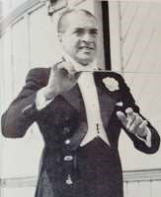
North End House in Station Road was occupied in 1901 by Ebenezer Medforth, 1838-1908, a farmer whose daughter Mary Selina, known as May, married F Lionel Johns a former violinist with the Halle Orchestra who was a light orchestral conductor when seaside orchestras were flourishing. There exists a photogragh of him, immaculate in white tie and tails when he was known as “The idol of St. Annes.” He also worked at Bridlington at the time of the 1937 coronation. His wife gave the polished oak desk in the vestry of Middleton church in memory of her mother who died in 1938.
In 1940 the Parish Council noted the provision of ten houses by the County Council to be named South Drive and in 1948 more from the same source to form Millfield Garth. In the 1970s Greenfield Road development and The Paddocks took place with mixed reactions from villagers; some feared the change in the character of the village; others believed that change from what had been basically an agricultural settlement to a residential one with inevitable suburban features was the way forward.
Following on from the development of the old Manor Farm site and the conversion of the Rose and Crown pub there are now plans afoot to add to the housing stock of the village on land to the east of Station Road.
Geoff Wisher

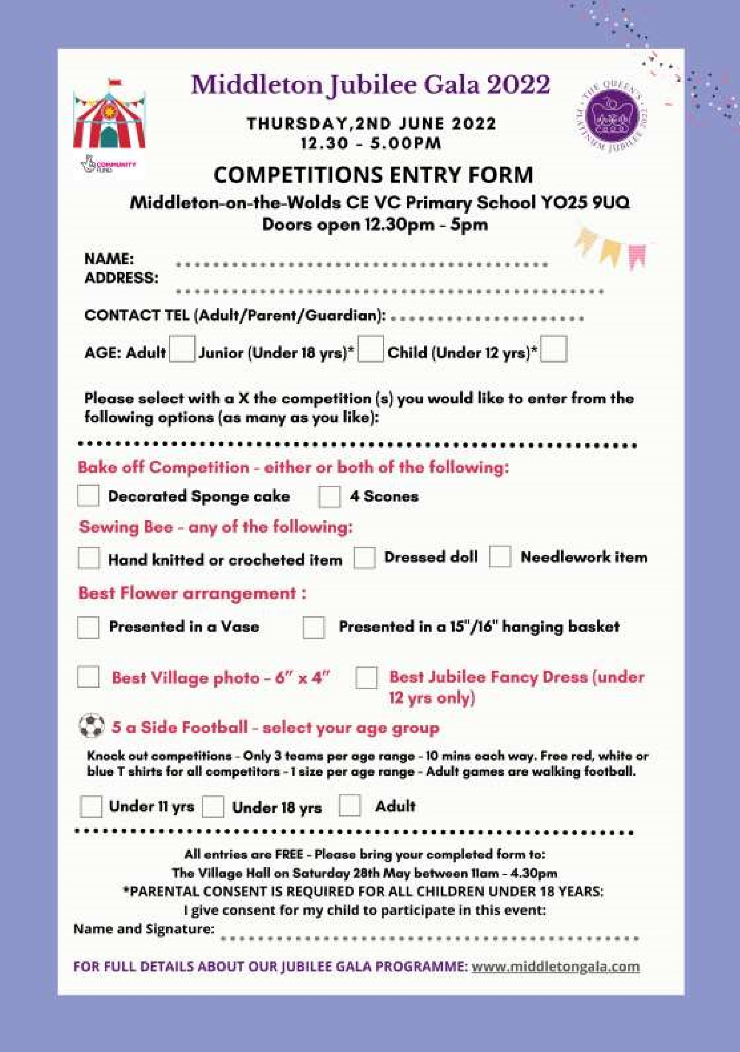

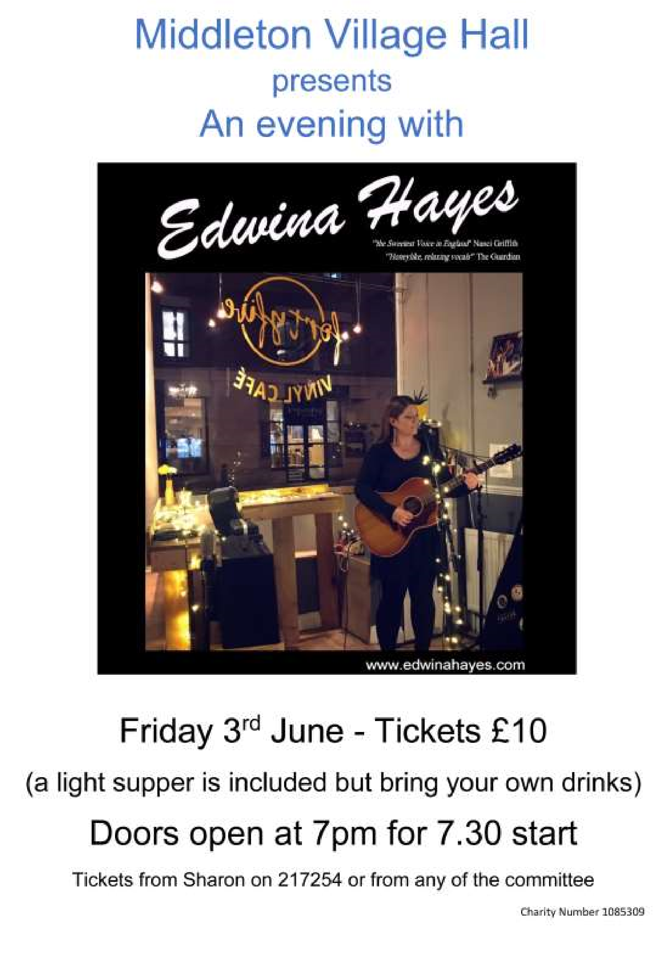

St Andrew’S church
Services for May

Sunday 1st | 10.30am | No Service
Sunday 8th | 10.30am | Holy Communion
 |  | Rev`d Jane Anderson
Sunday 15th | 10.30am | Holy Communion.
 |  | Rev`d Cannon Kate Goulder
Sunday 22nd | 10.30am | Rev`d Ruth Newton
Sunday 29th | 10.00am | Benefice Holy Communion. Venue TBA
May I thank all PCC members and others for the message in the April edition regarding my retirement as Church Warden
I has been an honour and privilege to serve both St. Andrews and the community, as well as the Harthill Deanery and the Diocese of York.
I wish our two new Church Wardens the very best, and to say I am always here to help during holidays etc.
Roger

The wolds METHODIST CHURCH
Services for May
Sunday 1st 10.30am | Service at the Wolds Methodist Church,
 | Miss Margaret Collinson
Sunday 8th 10.30am | Service at the Wolds Methodist Church,
 | Mr Keith Russell
Sunday 15th 9.00am | Café style service with breakfast at the Wolds
 | Methodist Church, Rev Dr Richard Teal.
 | Holy Communion
Sunday 22nd 10.30am | Service at the Wolds Methodist Church,
 | Mrs Hazel Adamson
Sunday 29th 10.30am | Service at the Wolds Methodist Church,
 | Mr Hector Robinson

parish council news

NEW SIGNS IN THE VILLAGE
Last month saw the installation of new signs in the village. A new bright yellow sign has replaced the old one at the Bowls Club and also indicates that the car park is intended for those who use the Recreation Club. Further signs have been positioned in the Rec club itself, pointing out the rules of entry including during sporting events for the requirement of dogs to be on leads. The Parish Council has also installed a ‘ Poo bag dispenser’ for those who need a bag for their dog whilst on the field. It is situated at the entrance where there is also a bin to deposit any used bag. The dispenser will be regularly checked and topped up but if found empty please e mail Nick on nj@motwparishcouncil.co.uk.
PLEASE DO NOT ALLOW YOUR DOG TO FOUL ON THE REC FIELD, ALLOTMENTS, BEACON
FIELD OR ON THE EMBANKMENTS. LETS KEEP OUR COMMUNAL AREAS CLEAN AND SAFE FOR ALL!
Other signs acknowledge the funding provided by East Riding Council and the FCC Communities Fund towards the newly installed play equipment, again please note that dogs are not allowed in the children’s play area and please take any rubbish away with you or put in the bin at the field entrance.
Thank You

Nick Jones
Parish Councillor
Dear Mike,
If you can remember, you made a walk around with 2 council members in Summer 2020 and I made a serious complaint about the poor condition of our main road through the village. sunken manholes, sunken rain drains, and a repair where the council threw tarmac onto a sunken stretch across the road, leaving a hump for all the trucks and lorries to literally bounce and bang across.
My complaint is that after reporting it not one repair has been made and here we are in Spring 2022, every household in the area can hear the banging from early hours to late evening, it's completely unacceptable, the repairs are not huge but they would make a huge difference to local residents mental and physical wellbeing, we are literally losing sleep with this issue, it NEEDS to be put right.
Please can you make it a priority and arrange with the correct authorities for the repairs asap, please can you let me know your thoughts and ideas Mike.
I look forward to your reply.
Yours sincerely
Lee Hardcastle
31 Front Street, MOTW
Dear Lee,
I remember you had raised this issue and I am well aware that the condition of Front Street has not changed in the last two years. I understand your frustration with the lack of action regarding the repairs.
Over the last two years we, ss a Parish Council, have worked closely with the County Council Highways department on resolving issues with the roads in Middleton and, in the main, we have had a constructive relationship with the highways department resulting in most of the agreed work being completed, especially in the last two or three months.
The situation regarding Front Street is a little more complex, As I understand it, rather than make a series of temporary repairs, the County Council decided to completely resurface the road. Although this work has been scheduled on at least two occasions, it has, on two occasions, been postponed; we have not been given reasons for the postponements.
We continue to chase up outstanding work, of which Front Street is an important element, and try to put pressure on the Highways department to move our work up the list. However, it is they who decide what jobs get done, and when.
I appreciate that this does not give you any definite answer to this specific question, but it is all the information I have; as soon as we learn anything about it, I will be sure to let you know.
Yours sincerely,
Mike Kelly
Advertisement
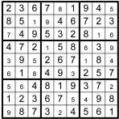
1

Roy Orbison

2

George V

3

Pound foolish

4

James Cook

5

Glasgow

6

Taggart

7

Yellow

8

Nokia

9

John Galsworthy

10

White

maypole

QUIZ ANSWERS

Advertisement

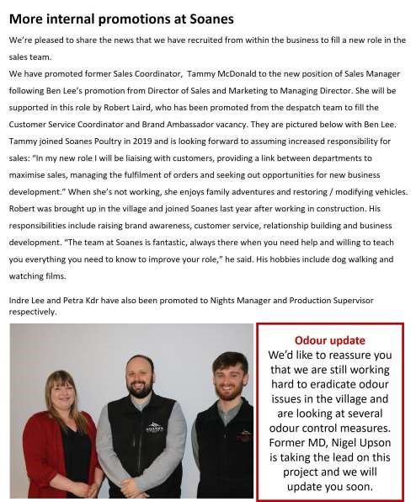
Advertising Feature

Advertisements
Advertisement

Advertising Feature

Regular group activities

Weekly Groups
Monday Pilates 5.00-6.00pm Village Hall Tuesday Tai Chi 2.30-4.00pm Village Hall
Wednesday Line Dancing 7.30-9.00pm Village Hall
Thursday Middleton Movers 2.00-3.30pm Village Hall

May
4 Village Hall Committee 2.00pm Village Hall
- Parish Council 7.00pm Reading Rooms
- Book Group 10.30am Village Hall
19 YCA 7.30pm Village Hall
22 Litter Picking Wombles 10.00am Lime View
LOCAL CONTACTS Bell Ringing Chris Atkin |  | 217285
Book Group/Middleton Movers | Lyn Dennis | 219500
Bowls Club | Rob Bradley | 217435
Country Women’s Association | Christine Johnson | 217374
First Responders | Chris Brent | 219469
Line Dancing | Pat Pottage | 217516
Methodist Chapel | Jane Gray | 07870 562455
Middleton Messenger | Mike Kelly | 07713 620912
 | Lyn Dennis | 219500
 | Tina Walker | 217242
Middleton Green Group | Liz Naylor | 219072
Middleton Womblers | Andrew Naylor | 219072
Parish Clerk | Sandra Morrison | 01262 470496
Pilates | Ian Stephenson | 07973 755717
Reading Rooms | Kath Bentley | 217456
Recreation Club | Dave Newlove | 07901 833784
St Andrew’s Church | Rev Jane Anderson | 219471
St Andrew’s Church Wardens | Chris Brent | 07766 162743
 | Lesley Kelly | O7907 451046
Table Tennis | Louise Newlove | 217801
Village Hall | Lyn Dennis | 219500
Village History Geoff Wisher |  | 217517
email: middletonflyer@yahoo.com page 28

